**SELECT, GROUP BY, AGGREGATE FUNCTION**

1. **Create following table. And insert following data**

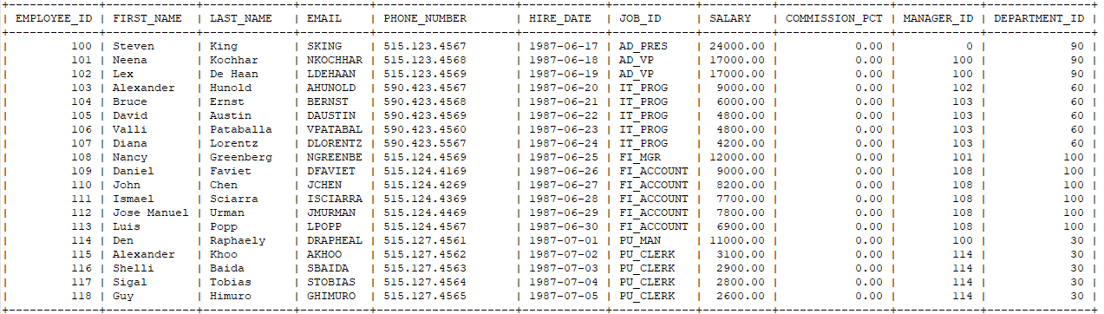

**2. Write a query to display the names (first_name, last_name) using alias name “First Name", "Last Name**

**3. Write a query to get unique department ID from employee table**

**4. Find total the number of employees in the table**

**5. Write a query to display the number avg salary of all employees**

**6. Write a query to display the number avg salary of all employees from each department**

**7. Write a query to display the number sum salary of all employees**

**8. Write a query to display the number sum salary of all employees from each department**

**9. Write a query to display all the employes with last name being sort in descending order**

**10.Write a query to display all the employees has character e in their first name**

**11.Write a query to display all the employees has character 2 characters a in their last name**